**TASK ON JENKINS**

Install Jenkins and run Jenkins on port number 8081.

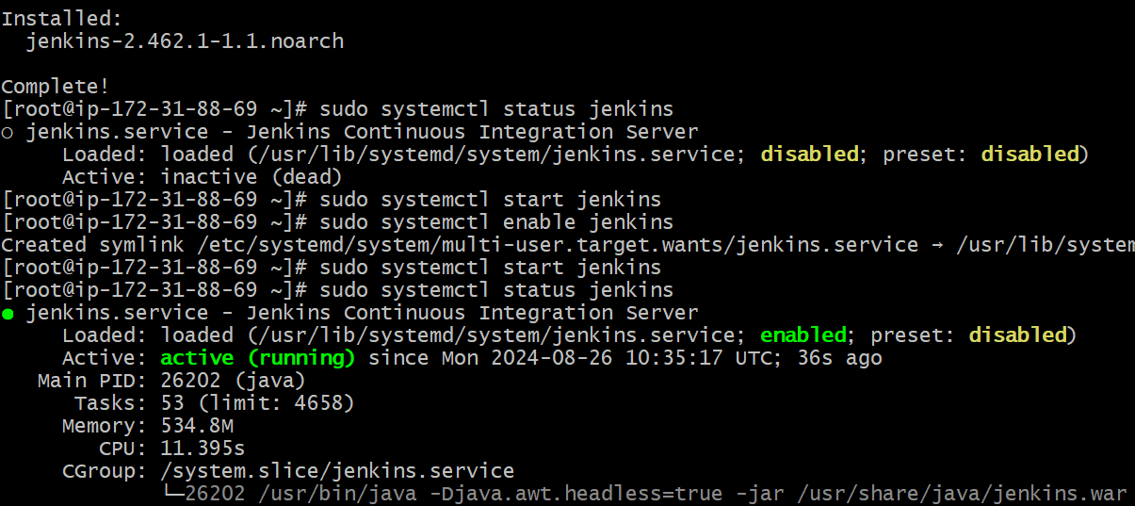

Secure Jenkins server

Secure with another password





Create users called DevOps, Testing in Jenkins with Limited access.

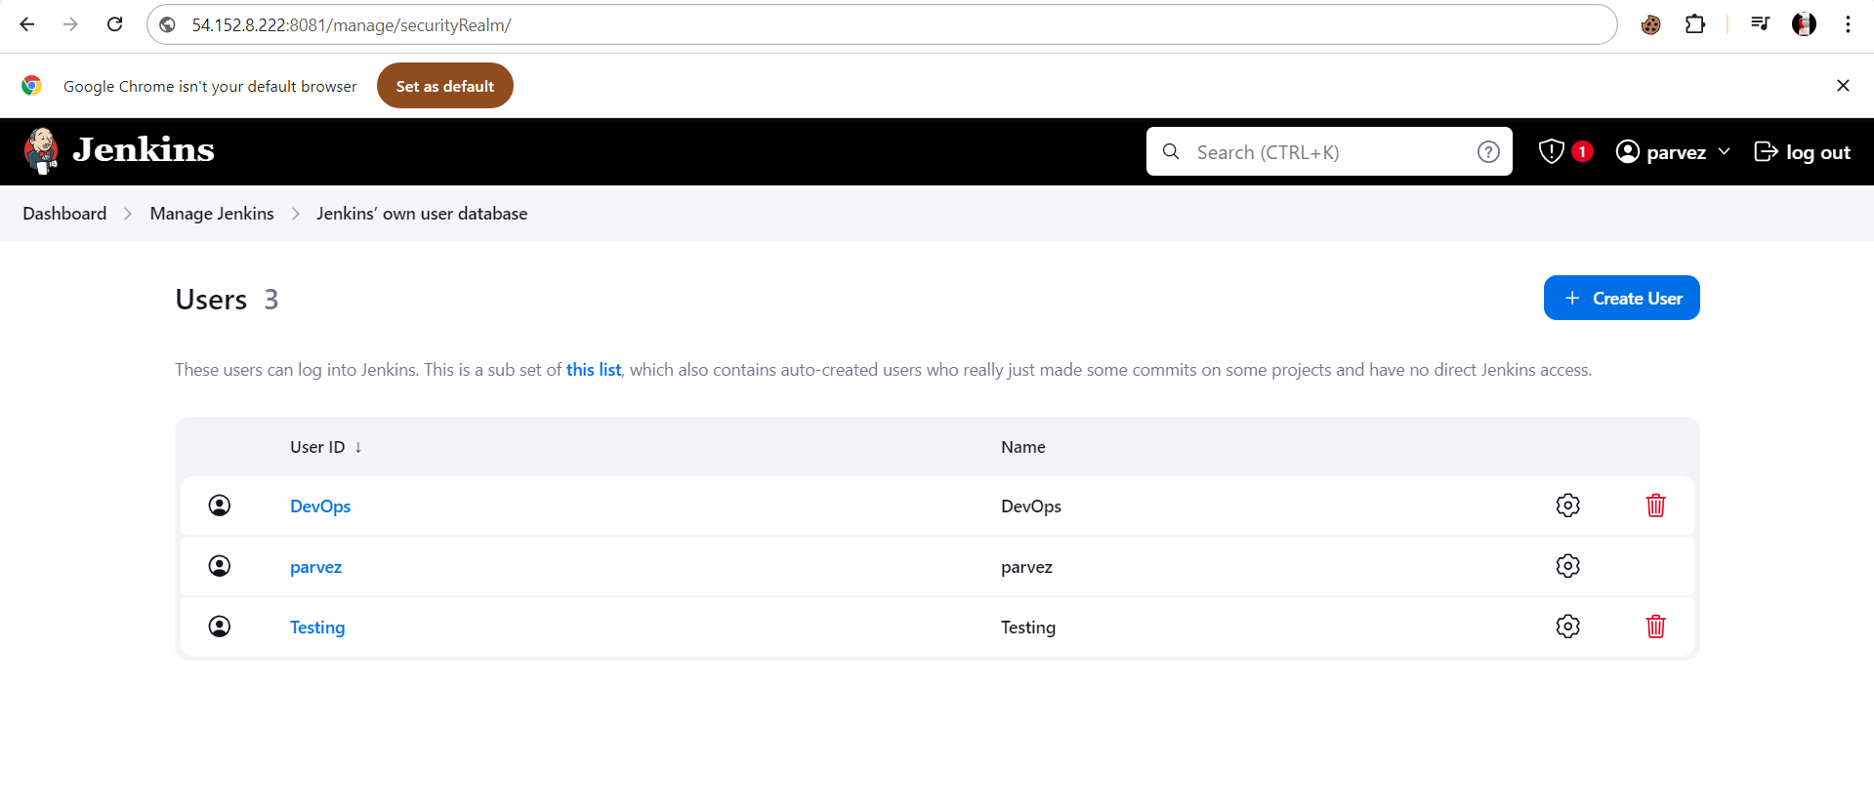

Configure labels and restrict the jobs to execute based on label only.

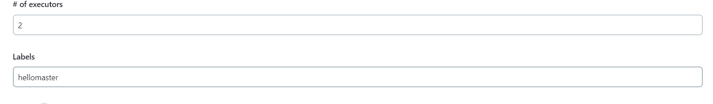

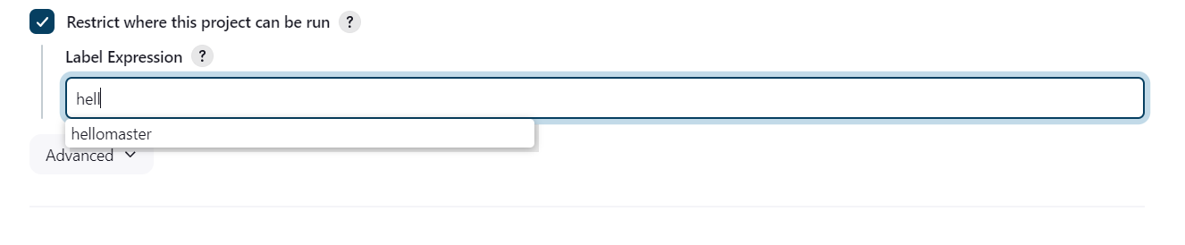

Create Three sample jobs using the below URL. <https://github.com/betawins/Techie_horizon_Login_app.git>

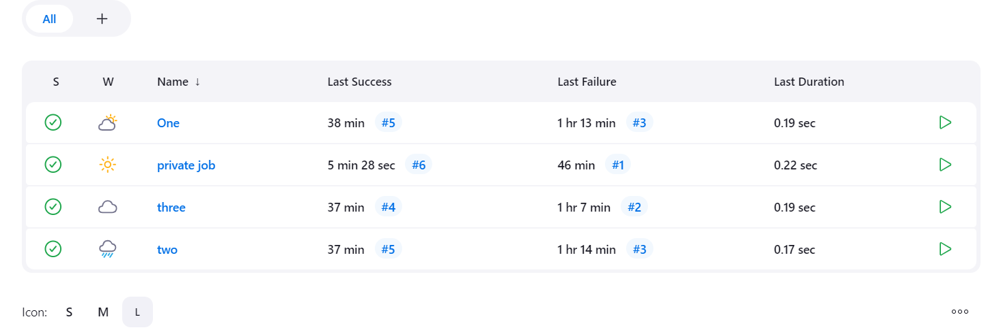

Create one Jenkins job using git hub Private repository.

